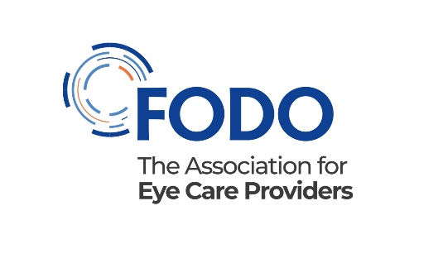
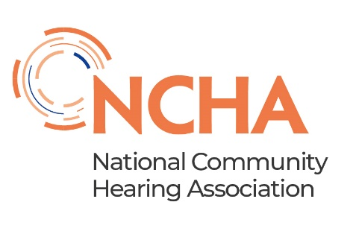

Job description

Public Affairs Officer

Reports to: |  | Heads of Policy and Public Affairs (FODO and NCHA)
 | Internal relationships: |  | Policy and Public Affairs Team  Colleagues  Members
External relationships: |  | Parliamentarians and strategic health influencers  Health regulators and policy-making bodies  UK governments and health services  Eye and hearing care sector professionals and organisations

Role summary
As the public affairs officer you will work closely within a small team with the heads of policy and public affairs at FODO and the NCHA within the FODO Group
Your role will be proactively to build the public affairs profile of the eye and hearing care sectors in the UK by
- raising awareness and understanding of the health value of eye and hearing care
- building positive relationships and identifying opportunities to help achieve organisation goals
- influencing policy and contributing to the delivery of strategy.

Purpose of role
- Support and deliver FODO’s and NCHA’s public affairs objectives for eye and hearing care.
- Help develop and maintain influential relationships with government, national bodies and other key stakeholders on behalf of members.
- Support the development of health policy, regulations and legislation.

Responsibilities
- Monitor the political environment, e.g. track the progress of bills and other parliamentary activity, sector news and other media, and feedback timely intelligence to colleagues to inform policy and external influencing activities.

- Obtain and analyse information about sector trends, threats, and opportunities, and use these to help shape policy and public affairs activities.

- Set up and curate database of key stakeholders and work with Heads of Policy and Public Affairs to develop strategically important messaging and relationships to advance and protect eye and hearing care in the UK

- Prepare high-quality briefing materials for political audiences and senior team members, and the wider memberships.

- Track and measure the impact of policy and public affairs initiatives.

- Help draft consultation responses, position statements and agendas and papers for relevant FODO and NCHA member committees and provide progress reports on public affairs activity to those groups.

- Develop partnership working with public affairs teams across the eye and hearing health independent, NHS and third sectors to support strategic aims.

- Develop social media and digital content, such as blogs, to support FODO’s and the NCHA’s public affairs activities. Support events (webinars, seminars).

- Work with Heads of Policy and Public Affairs to develop and deliver campaigns, including supporting with research and analysis.

- Opportunities to represent the organisation at relevant stakeholder meetings

- Other duties as required that are reasonable and within your capabilities.

Skills and knowledge

Essential

- Experience of developing and maintaining public affairs contacts in parliament, government and with other stakeholders,
- Excellent writing and speaking skills
- Good analytical and fact-finding skills and ability to present complex information in a straightforward way whether in writing or verbally
- Collaborative working style, enjoys working with others to achieve agreed influencing objectives
- Record of delivering effective results
- Personal drive and motivation
- Attention to detail, accuracy and timeliness
- Good IT (Microsoft Office) and social media skills.

Desirable

- Whitehall or Westminster experience – e.g., working in a Department or an MP’s office.
- Experience of public affairs within primary healthcare
- Understanding of regulation, health care and business.

Other information

- Flexibility – work flexible hours as reasonable and necessary to ensure you achieve tasks. Some out-of-hours meetings and overnight stays within the UK will be required.

- Absolute confidentiality and discretion – respect member and policy confidentiality at all times, following organisational controls.

- Equal opportunities and tackling inequalities – promote our corporate and policy goals of tackling inequalities in access to care and promoting and supporting the principles in the Equality Act and similar legislation.

